Name: __________________________ Student ID: _________________
BN5101 Biomedical Engineering Systems
Virtual laboratory Activity (Due end of class)
Maximum Score: 75 points

Questions | Points
1 | /19
2 | /20
3 | /12
4 | /24
Total | /75

Objective of Virtual laboratory Activity
To increase your understanding of cell cycle regulation by providing you with the opportunity to conduct and analyze data from a set of biological analytical methods (Flow cytometry, western blot and fluorescent microscopy) in a virtual lab simulated environment. To conduct the virtual experiments, you will use StarCellBio, a cell and molecular experiment simulator software to design experiments under the appropriate experimental conditions and analyse the experimental results to identify the role of the targets of mutant RNAs #1-3 involved in cell cycle regulation.

Instructions for logging to StarCellBio:
Step 1: Go to http://13.251.53.155:8100/
Step 2: Click on “create student account”
Step 3: Sign up with “your email account and create your own password”
Step 4: Course code will be “BN3402”
Step 5: After signing in, click on choose “BN5101 cell cycle regulation” to start on simulated experiments
Background Information
You are studying novel regulators of the cell cycle. Your lab mate has produced mutant RNAs that result in a cell cycle phenotype by decreasing the expression of unknown cellular targets genes. You are asked to design a series of experiments that will further characterize the cell cycle phenotypes resulting after mutant RNAs 1-3 treatment and determine the role of their targets in cell cycle progression.
To do this you will use 3 different techniques: flow cytometry, western blotting and microscopy. In addition to mutant RNAs #1-3, you are provided with an RNA (called “Control”) that does not affect cell cycle progression and which you can use to compare the results of mutant RNAs #1-3 treatments. For this activity, you can assume that each mutant RNA targets only a single gene product. Within StarCellBio, you will first set up an experiment by adding one mutant RNA at a time to the provided cells. The experiment will then be run, and the resulting samples can be used for any of the given experimental techniques.

1. Flow Cytometry
The lab recently acquired an easy-to-use, bench-top flow cytometer. You are to conduct a DNA content analysis of your cells by using propidium iodine (PI), a fluorescent dye that binds to DNA. The amount of fluorescence signal that is detected by the flow cytometer within a cell is proportional to the amount of DNA present. Since the flow cytometer allows for the quantitation of DNA content of each cell within population, analysis of the resulting fluorescent signals will allow you to determine the percentage of cells within each stage of the cell cycle within the given population. Using StarCellBio, you are to generate the histogram of PI fluorescence, where the X-axis represents the intensity of PI fluorescence and the Y-axis represents the number of cells detected within each PI intensity. Cells with DNA not yet replicated (G0/G1 phases of the cell cycle) will contain half the amount of DNA and therefore half the fluorescence as cells that have replicated their DNA (late S and G2/M phases).

2. Western Blotting
In addition to analyzing the DNA content in mutant RNAs #1-3 treated cells, you determine the relative expression of several key cell cycle regulators by using western blotting. The intensity of the band on the western blot for a given protein is proportional to the amount this protein present inside cells. Using the samples you previously collected, conduct a series of western blotting experiments to determine the relative levels of key cell cycle regulators for which reagents are available. You have the following antibodies available to you, including an antibody against a housekeeping gene whose levels do not change throughout the cell cycle.
Antibody | Description | Expected molecular weight of detected band(s) (kDa)
Mouse anti-cyclin B | Primary antibody recognizing Cyclin B. | 58
Mouse anti-cyclin E | Primary antibody recognizing Cyclin E. | 48
Rabbit anti-cohesin | Primary antibody recognizing cohesinc1 (subunit of cohesin)* | 68 (full length)  28, 20 (Partial Length)
antibody housekeeping protein | Primary antibody recognizing the housekeeping gene | 45
Goat anti-rabbit  Rabbit anti-mouse | Secondary antibody recognizing rabbit primary antibodies.  Secondary antibody recognizing mouse primary antibodies. | N/A  N/A

3. Microscopy
Finally, you visualize the cells’ DNA and spindles using the following fluorescence microscopy analyses, as indicated within the microscopy setup page. You take images at a magnification and resolution that allows the chromosomes and mitotic spindles within the nucleus to be discerned. For mutant RNA conditions in which multiple cell cycle stages are present, you take a representative set of images from each of the cell cycle stages that you see.

Fluorescence microscopy Analysis | Description | Notes
DAPI (blue), α-tubulin (green), γ-tubulin (red) | DAPI; 4',6-diamidino-2-phenylindole, a fluorescent stain that binds to DNA  α-tubulin antibody; a marker of microtubules  γ-tubulin antibody; a marker of spindle poles | For some mutant RNA treated cells, the image provided represents a composite image of representative images of cells in the various stages of the cell cycle present in that sample. For each mutant RNA condition, make sure to scroll left and right on the microscope’s view finder to ascertain if a composite image is present for that sample.

Conduct the appropriate experiments within StarCellBio to characterize the effect of each mutant RNA, mutant RNAs #1-3, on cell cycle progression. Using the results that you obtain from these experiments, answer the following questions.

Question 1 (19 points)
Using StarCellBio, analyse the flow cytometry results and indicate the percentage of cells within each stage of the cell cycle for each mutant RNA treatment. [12 points]
 | % of cells in G1 | % of cells in S | % of cells in G2/M
Control | 86 | 4 | 10
mutant RNA #1 | 0 | 0 | 100
mutant RNA #2 | 0 | 4 | 96
mutant RNA #3 | 68 | 9 | 23
Note: These percentages reflected here do not take into consideration the percentage of cells in mutant RNA #3 treated cells that appear to have < 2C and >4C DNA content.

Flow Cytometry Results:
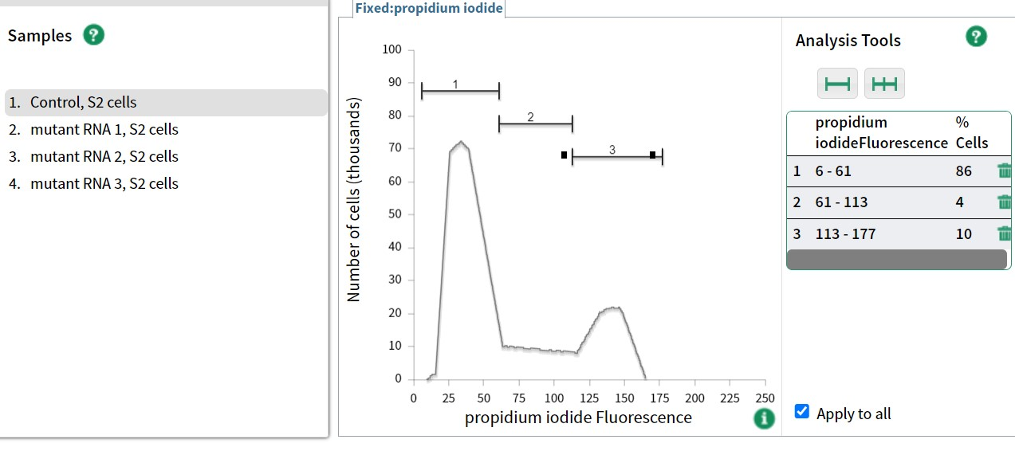
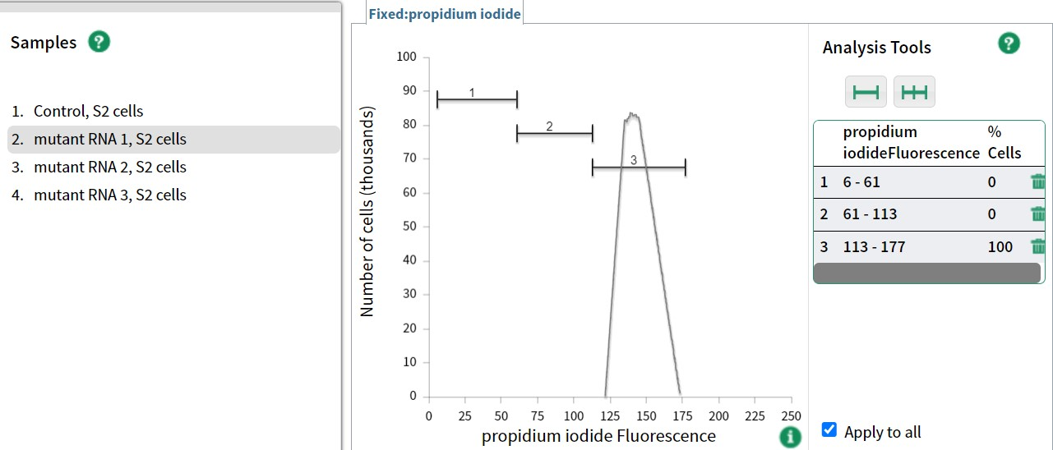
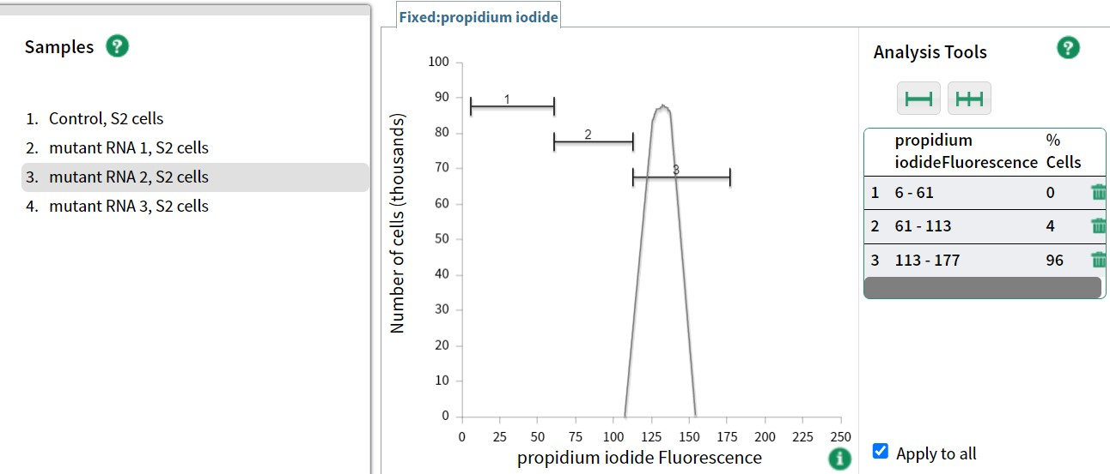
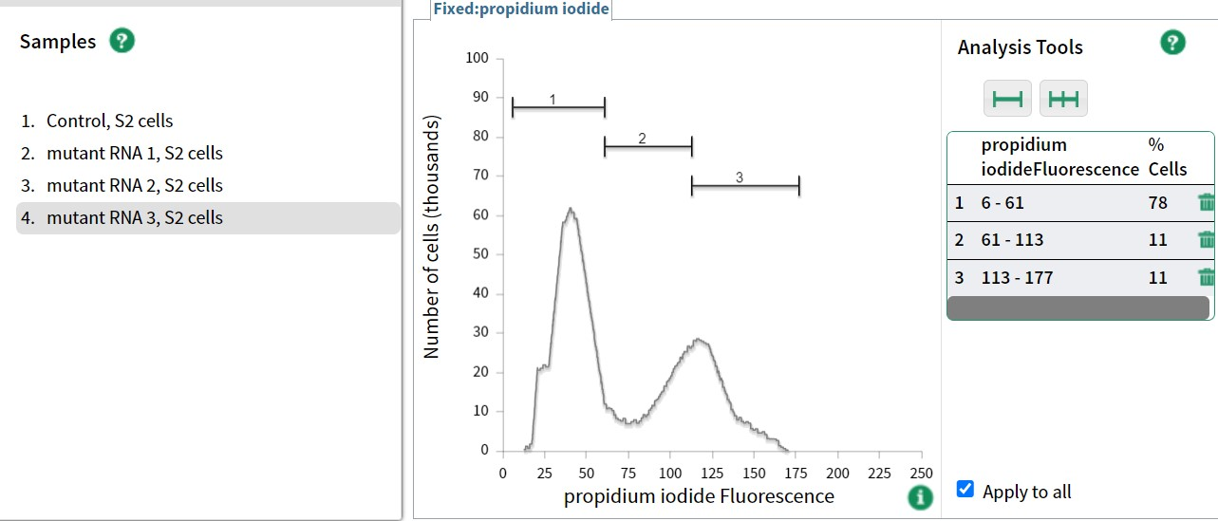

Part A
Using the data above, describe the differences in cell distribution between Control and mutant RNAs #1-3 treated cells. [3 points] Hint: Answer with respect to percentage of cells and DNA content
[1 Point] Mutant RNAs 1 and 2 have one peak (~>100 units) of PI fluorescence, compared to two peaks in Control RNA cells.
[1 Point] Mutant RNA 3 treated cells show cells with >4C and <2C DNA content, compared to Control treated cells that lack these types of content.
[1 Point] Mutant RNA 3 has 2 peaks that correspond to 2C and 4C DNA content, with its percentage differing from that of Control RNA.
Part B
Using only your flow cytometry data, describe how is each of the mutant RNA treatment affecting cell cycle progression? [3 points]
[1 Point each] The flow cytometry data indicates that mutant RNA #1 and mutant RNA #2 treated cells are arrested in G2 or M phase.
[1 Point] The flow cytometry data indicates that mutant RNA #3 treatment leads to abnormal chromosome numbers.
Part C
Suggest a reason why the G2 and M cell cycle phases cannot be discerned in your flow cytometry set-up. [1 point]
[1 Point] Cells in G2 and mitosis have the same DNA content which is why it is not possible to distinguish them using PI fluorescence.

Question 2 [19 points]
Part A
Using your experimental results for mutant RNAs #1-3, indicate whether cyclin E and B are expressed less, more or about the same, if cohesin is cleaved or uncleaved relative to the RNA Control cells in the table. [12 points]
 | Cyclin E | Cyclin B | Cohesin | Housekeeping protein
mutant RNA #1 | Not Detected | More Expressed | Uncleaved | Same
mutant RNA #2 | Not Detected | More Expressed | Uncleaved | Same
mutant RNA #3 | Detected | Same | Cleaved | Same

Suggest a reason for including the housekeeping protein in your western blotting analysis. [2 points]
[1 Point] Housekeeping protein act as an internal control for sample loading.
[1 Point] It is to ensure that the same amount of cell samples is the same in all the cells, so that it allows a fair comparison of protein expression between different treatment group.

Part B
Based on the results you obtained in your western blotting analysis, which of the following phase best described the mutant RNAs 1-3 cells are in? Select the correct option. [3 points]. Hint: Levels of cell cycle regulators.
For Mutant RNA #1:
1) G1
2) S
3) G2 or M
4) At different stages of cell cycle

For Mutant RNA #2:
1) G1
2) S
3) G2 or M
4) At different stages of cell cycle

For Mutant RNA #3:
1) G1
2) S
3) G2 or M
4) At different stages of cell cycle
Part C
Using the experimental data from western blot (or flow cytometry where possible), briefly explain your selection above for mutant RNA#1-3. [3 points].
[1 Point each] For mutant RNA #1 and mutant RNA #2 treated cells, higher levels of cyclin B and undetectable cyclin E is indicative of cells that have progressed out of S and are either in G2 or M phase. Uncleaved cohesin1 for both mutant RNA treatments indicates that cells are either at G2 or M phase prior to segregation of chromosomes.

[1 Point] For mutant RNA #3 treated cells, the WB results show similar levels of cyclin B, cyclin E expression, and cohesin cleavage as the Control RNA treated cells, which is indicative of a population of cells that are at different stages of the cell cycle (G2/M, S phase, and late M, respectively) as previously indicated by flow cytometry.
Western Blot Results:
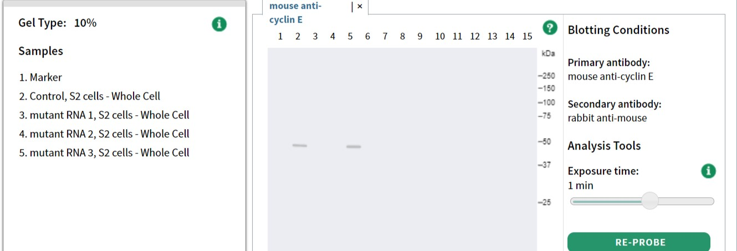
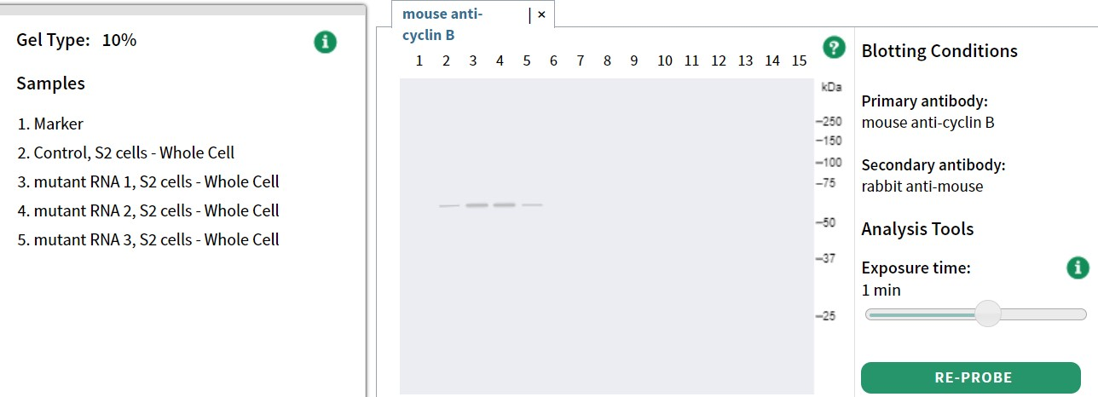
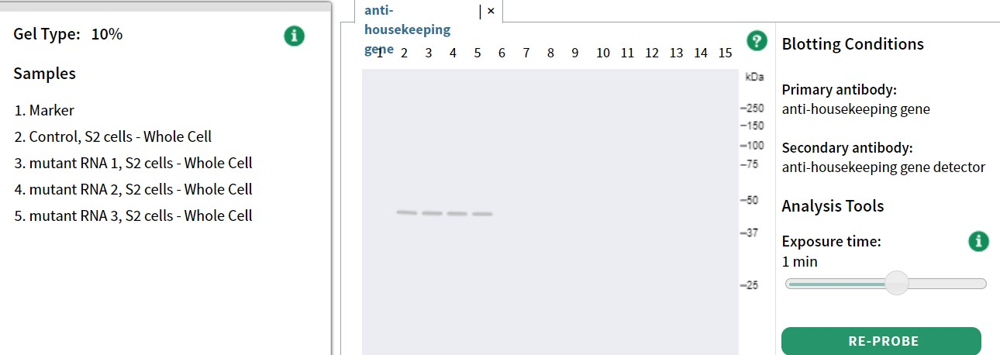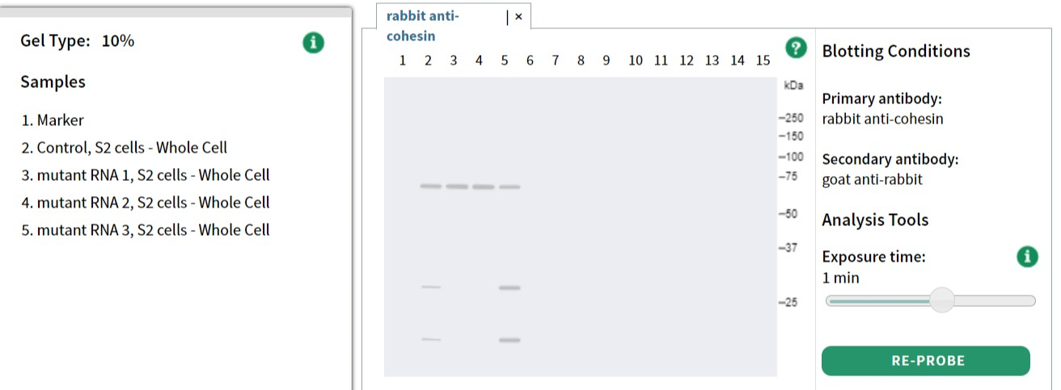
Question 3 [12 points]
Part A
Looking at your fluorescence microscopy images, what do you observe about the chromosome structure and spindle assembly in mutant RNAs #1-3 cells as compared to Control RNA cells? [12 points]
 | Chromosome Structure | Spindle Assembly
mutant RNA #1 | Chromosomes are aligned at the middle and their configuration seems indistinguishable/same/similar from that of one sub-population of the control cells (Mitosis phase), | Spindles are oriented in a bipolar fashion.  Their length and configuration are indistinguishable from that of one sub-population of the control cells (Mitosis phase)
mutant RNA #2 | Chromosomes are not properly aligned at the middle and their configuration seems different from that of Control cells. | Spindle poles are positioned at opposite ends of the cells.  Spindles are smaller in comparison to those in Control cells.
mutant RNA #3 | Images show cells that are in interphase (cells in G1, S and G2) as well as cells in mitosis.  For those in mitosis, the chromosomes appear to be separating. However, chromosomes appear to be separating unequally. | For those cells that are in M phase, spindles are oriented in a bipolar fashion.  Their length and configuration are indistinguishable/same/similar from that of Control RNA treated cells.

Microscopy Results:
Control
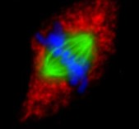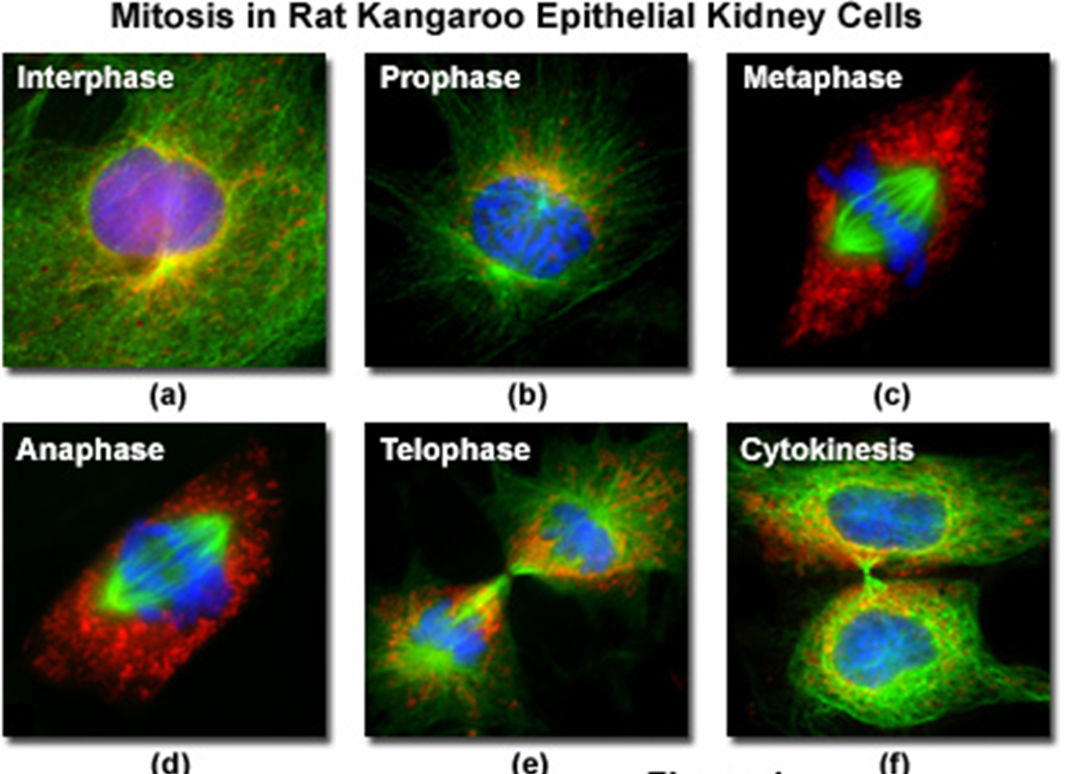
Mutant RNA #1 Mutant RNA #2
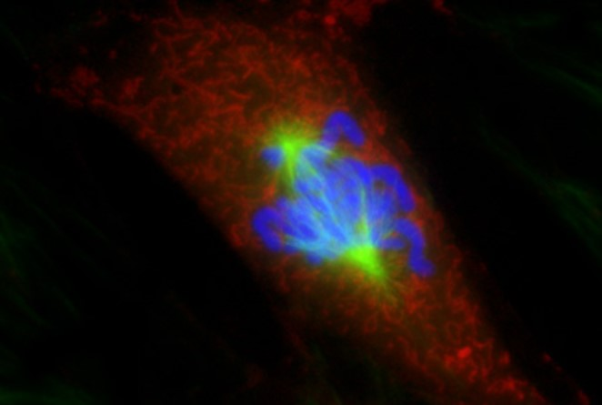

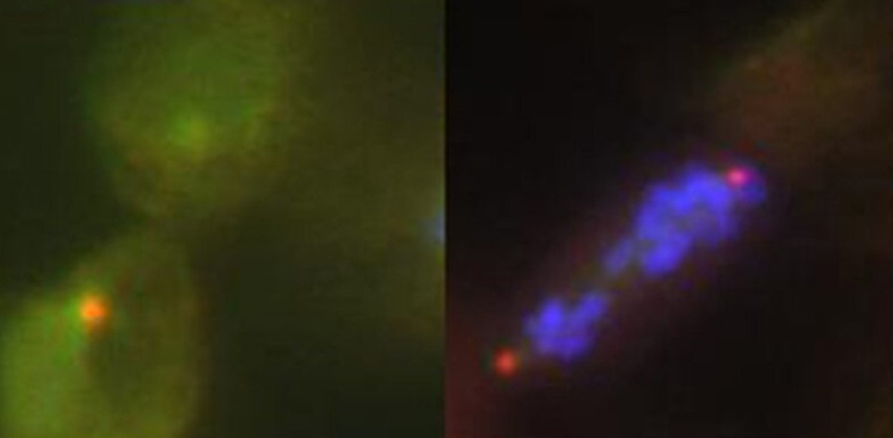
Mutant RNA #3

Question 4 [24 points]
Part A
Propose a hypothesis that could explain how each of the mutant RNA treatments affect cell cycle progression within the context of this class or lab activity. Explain your reasoning and be sure to use your combined experimental results from flow cytometry, western blotting and microscopy analyses in your justification. [15 points] Hint: Include the cell cycle, spindle assembly and phase cell cycle regulators in your answers.
 | Flow Cytometry Analysis  (1 point) | Western Blotting Analysis (1 point) | Microscopy Analysis (1 point) | Hypothesis (2 points)
Mutant RNA #1 | majority of the cells has 4C of DNA amount, suggesting cells are in G2/M stage | Cyclin E not detected (not S phase); Cyclin B levels are high (in M phase) and Scc1/cohesin is uncleaved (before anaphase in M phase) | chromosomes were able to align in the middle with bipolar spindle attachment/spindle attachment appears normal | Arrested at M phase/Metaphase
Mutant RNA #2 | majority of the cells has 4C of DNA amount, suggesting cells are in G2/M stage | Cyclin E not detected (not S phase); Cyclin B levels are high (in M phase) and Scc1/cohesin is uncleaved (before anaphase in M phase) | chromosomes are condensed and can be seen/visible, not aligned in the middle and spindles are short (before metaphase in M phase) | Arrested at M phase/either late in prophase or early in metaphase
Mutant RNA #3 | Some proportion of cells in with <2C and >4C DNA content indicates that mutant RNA #3 leads to abnormal chromosome numbers | Cyclin E is detected (in S phase); Cyclin B levels are present (in M phase) and Scc1/cohesin is also cleaved (progress to anaphase in M phase), suggesting cells are in different stages of the cell cycle | sister chromatid separation/improper separation of sister chromatids with unequal chromosome distribution | Not arrested in any phase, but abnormal chromosome numbers have produced abnormal amounts of DNA content, suggesting M-phase checkpoint mechanism is mutated

Part B
Suggest a possible target (protein) for each of the mutant RNA #1-3 within the context of this class or lab activity. Support your answer with experimental evidence where possible [12 points] Hint: Refer to spindle assembly checkpoint diagram

 | Mutant RNA #1
Targets  (1 point) | [1 point] Separase or APC
Explanation  (2 points) | [1 point] Decrease in separase or APC will result in metaphase arrest as there will be no cleaving of cohesion. The chromosomes and spindles that are bipolarly attached and aligned at the metaphase plate.  [1 point] Cells will have 4C amount of DNA and with high levels of cyclin B, indicating they are in M-phase

 | Mutant RNA #2
Targets  (1 point) | [1 point] Exact target unknown but likely protein important for spindle chromosome attachment or protein important for microtubule stability
Explanation  (2 points) | [1 point] Cells will have 4C amount of DNA and with high levels of cyclin B, indicating they are in M-phase (before metaphase). Furthermore, cohesin is not cleaved indicates that these cells are at a stage prior to segregation.  [1 point] The spindles are short, and chromosomes are not aligned in the middle, indicating a defect in the ability to form and sustain proper spindle-kinetochore attachment.

 | Mutant RNA #3
Targets  (1 point) | [1 point] Mad2 or Securin
Explanation  (2 points) | [1 point] Due to the lack of Mad2 or securin, cells will not be able to correct improper microtubule kinetochore attachments before proceeding into anaphase.  [1 point] Any chromosomes that lack proper bipolar attachment will segregate improperly in anaphase. This will result in unequal chromosome distribution during anaphase and abnormal chromosome numbers, indicated by >4C amount of DNA, levels of cyclin B, and cleaved cohesin.

